Project 3- Solution

These are the steps we need to perform:

Step 1:- Login to AWS Management Console and Go to the AWS Cloud Formation Service Page.

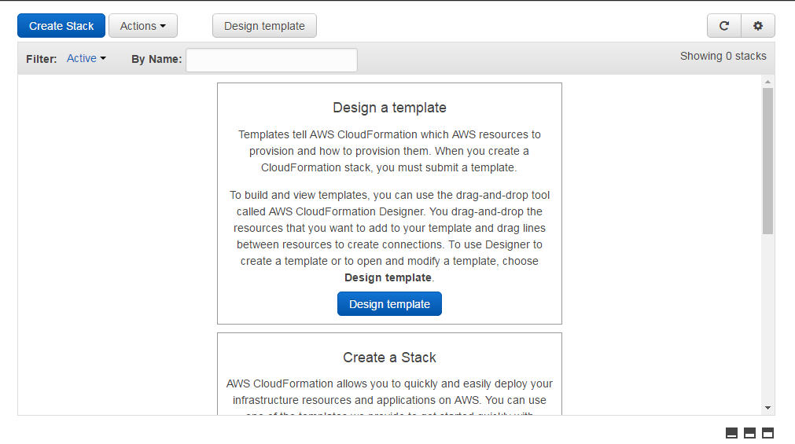

Step 2:- Write a Cloud Formation Script for Creating Amazon S3 Bucket in Notepad (using default Amazon S3 Settings) and save it as s3.json.

{

"AWSTemplateFormatVersion" : "2010-09-09",

"Resources" : {

"S3Bucketoct28" : {

"Type" : "AWS::S3::Bucket"

}

}

}

Step 3: Then, Click on the Create Stack and upload the s3.json file from your local system; click on next

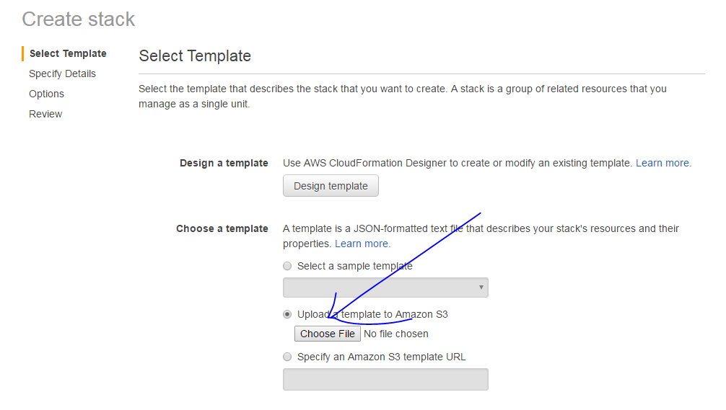

Step 4: Provide the Amazon stack name “s3test” and click on Next

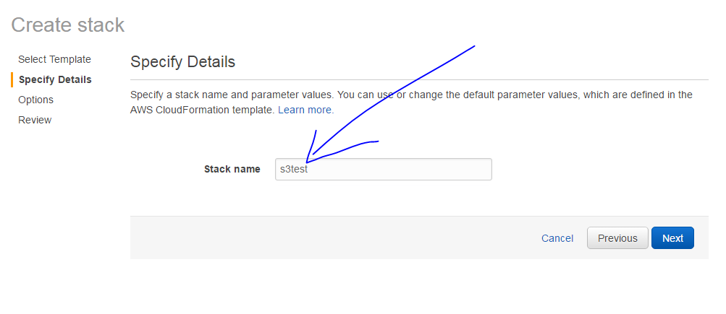

Step 5: Keep the default setting. Click on next again. You will get this screen. Then, click on the Create Tab.

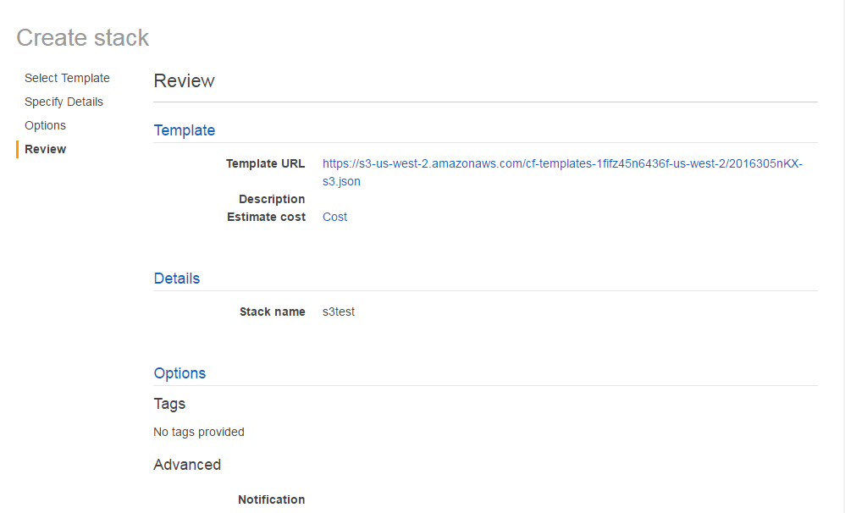

Step 6: You can Track the Progress of AWS Resource Creation.

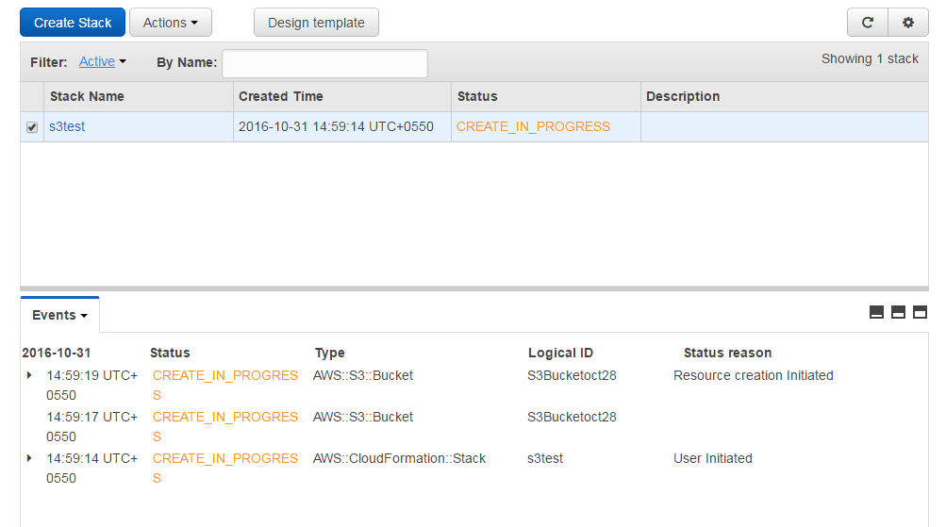

Step 7: Once you see the status “Create_Complete,” check the newly created Amazon S3 Bucket.

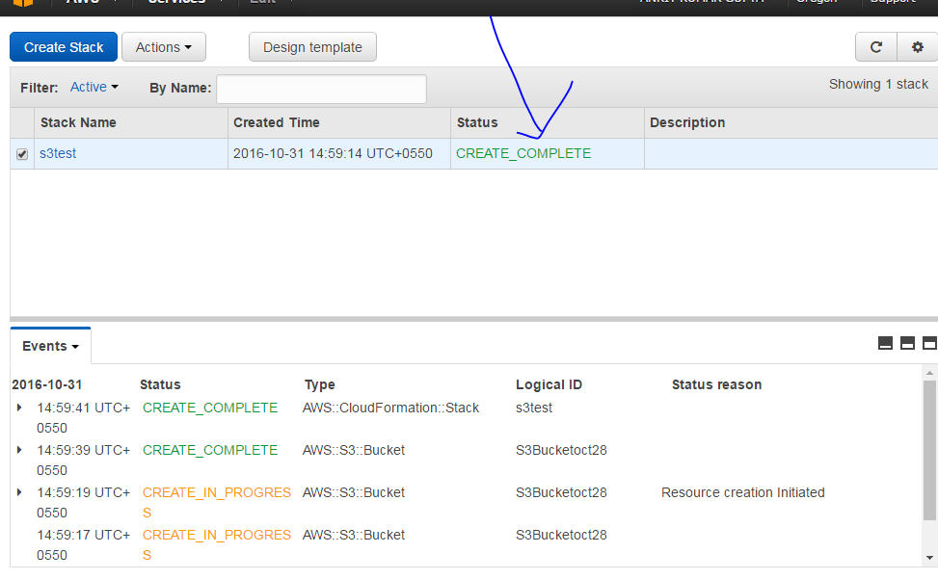

Step 8: This is the bucket created using Cloud formation

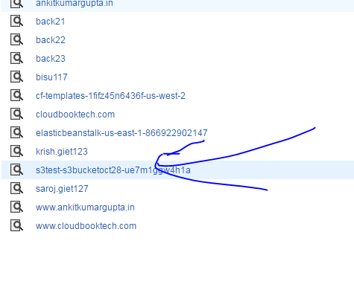

Step 9: Go to Cloud Formation Page and delete the stack “s3 test”. This will delete the Amazon S3 Bucket created using Cloud Formation Script.

